Certified Precision Diameter Tapes
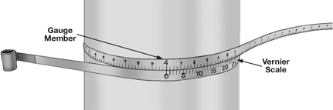
Accurate to ±.001" and ±.03 mm, these metal ribbon tapes are great for determining true diameters. All include a certificate of accuracy traceable to NIST (National Institute of Standards and Technology) and have engraved and acid-etched graduations that convert circumference distance into diameters. Tapes come furnished in a tin canister.
To use, snugly wrap this tape around your object. Find the value on the gauge member that's closest (to the left) of zero on the vernier scale. Next, find the value on the vernier scale that aligns with a value on the gauge member. Add the two values together to get your true diameter.
Choose Type 420 stainless steel for corrosive environments.
Tape |  | Type 1095 | Type 420
Diameter | Tape | Spring Steel | Stainless Steel
Range | Width | Each | Each
Inch: Inches to .001" diameter.
.75" to7" | 1/2"
  $112.00
2" to12" | 1/2"
  68.92
  112.00
2" to24" | 1/2"
  108.31
  151.38
12" to24" | 1/2"
  75.08
  118.15
12" to36" | 1/2"
  115.69
  158.77
24" to36" | 1/2"
  81.23
  124.31
24" to48" | 1/2"
  121.85
  177.23
36" to48" | 1/2"
  87.38
  142.77
48" to60" | 1/2"
  98.46
  153.85
60" to72" | 1/2"
  108.31
  163.69
72" to84" | 1/2"
  115.69
  183.38
84" to96" | 1/2"
  129.23
  196.92
96" to108" | 1/2"
  135.38
  203.08
108" to120" | 1/2"
  141.54
  209.23
Metric: cm to .01 mm diameter.
100mm to 300mm | 1/2"
  83.69
  —— | ——
300mm to 600mm | 1/2"
  89.85
  —— | ——

McMaster-Carr Catalog – 2003 www.mcmaster.com

